2024 / 2025 Fundraising Internship
Working in the charitable sector as a fundraiser can be very rewarding. It is a career that is full of achievement and contribution, where you get to know on a regular basis how you can make a difference. You get to connect to connect people, businesses, and organisations to achieve a shared goal, and raise money to make ideas happen. It can be fun, fast-paced, and full of feel-good.
It is a role that is highly varied and builds transferrable skills for a number of sectors:
Sales; marketing & communications; event management; project planning & management; finance (including developing & monitoring budgets); data handling & analysis; governance & compliance

Working as a fundraiser in an Arts charity gives you an added bonus: It allows you to understand all the ways to attract funding to develop your own creative practice, and how to sustain those relationships: You learn how to ask for money (the all-important case for support) and the steps that are vital to ensure that you can keep asking.
As a fundraising intern, you will get to develop a number of key skills that are attractive to many employers:
Enthusiasm and commitment; the ability to ask; persuasiveness; confidence / dealing with rejection; persistence; truthfulness; contacts; good organisational skills, including time management; good social skills; imagination and creativity; problem solving; the ability to grasp opportunities
Fundraising Internship at Ledbury Poetry
For almost thirty years, Ledbury Poetry has been delivering its flagship summer festival which runs in the first week of July each year. It is international, inclusive, and inspiring – recognised as one of the most exciting poetry festivals in the world, hosting both renowned and up-coming poets, and attracting audiences from across the globe. Alongside the festival, Ledbury Poetry runs a broad outreach and engagement programme, including activities with children and young people, the local community, new writers, emerging critics, and international projects.
In 2021, Ledbury Poetry moved into The Barrett-Browning Institute, an iconic building centrally located on Ledbury’s High Street. It was underused and in desperate need of refurbishment. Trustees, volunteers, and staff have since worked to breathe new life into it. The building has two useable floors and capacity to accommodate 100 people. It is a work in progress, and funding is currently being sought to develop the space further.
In November 2022, The Arts Council for England renewed Ledbury Poetry’s funding status as a National Portfolio Organisation and received additional funding to develop the organisation further. This is secured until Spring 2026, with the possibility to extend through to March 2027.
In September 2023, Ledbury Poetry appointed its first dedicated fundraiser, who is also member of the Chartered Institute of Fundraising (CIOF). All fundraising internships will be mentored by Ledbury Poetry’s fundraiser and have access to a tailored competency framework developed by the Chartered Institute of Fundraising – this supports career development (see diagram below).
Ideally, we are looking for a fundraising intern to cover a 12-month period but can accommodate shorter requests. Please note that work experience opportunities (for 2- 3 weeks) are also available, but these are different to our internship programme.
KEY DUTIES
The fundraising intern will provide support to Ledbury Poetry’s fundraiser. This is a training opportunity so you will get to experience all aspects of a fundraiser’s job.
These could include:
- Researching funding opportunities
- Maintaining databases and records
- Developing fundraising proposals
- Supporting the planning and delivery of events
- Writing reports and thank-you letters (supporter stewardship)
Please note that your internship will be tailored to ensure that you develop the skills and outcomes to enable your own career development plans. Goals will be set, and you will work with Ledbury Poetry’s fundraiser to ensure that you can achieve them.
PERSON SPECIFICATION
Fundraisers come from in all shapes and sizes which is why it is such a great sector to work in. You might want to consider how you already display the key skills that have been outlined above, and which you will develop in role.
You must be 18+, have GCSE English & Maths, and good computer skills.
Most important are the values you hold, and you will need to provide clear evidence to demonstrate these: Honesty; Respect; Integrity; Empathy; Transparency.
Above all, you will need to demonstrate passion for the cause you are fundraising for i.e. The Arts, and Poetry.
The internship is unpaid, but you WILL get to work with a charity that is renowned internationally for its work, has ambitious plans, a great team of people working for it PLUS free tickets to all its events and plenty of tea, coffee, and cake (if you want or need it).
Please apply for this internship programme to Emma.Jackson@ledburypoetry.org.uk
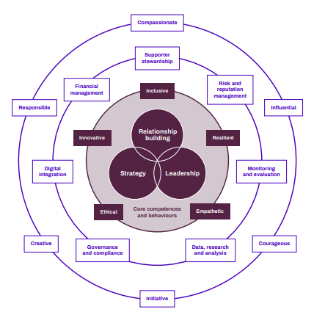
THE CHARTERED INSTITUTE OF FUNDRAISING:
COMPENTENCY FRAMEWORK

